**Getting Started With Hattrick**

**Game Goal:**

As a soccer manager your job is to manage a soccer team so that you win as many matches as possible and finish the soccer league at the first place.

**Game Rules:**

Every week a game is played according to the league cycles, until every team played every other team exactly twice. For instance a 6 team league will have 3 games each week, resulting in 10 cycles (each team plays 10 games during the league).

**Entering the game:**

First, you have to create a user for yourself.

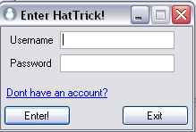

Just click the “Don’t have an account” and you’ll be right on the way to become a soccer manager.

**Game tools:**

**League Table:**

The first screen you will see is the League table. It Shows you the current standings of your team against the other teams in the league.

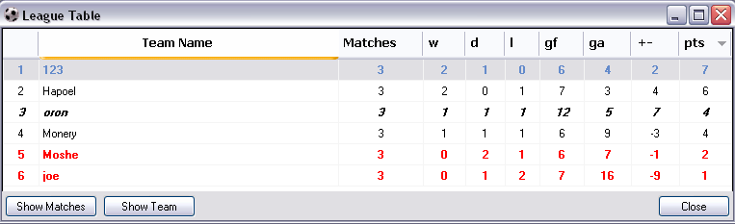

Your team will be marked by ***Italic bold***. The current league winning team will be marked with green, and the two bottom teams are red.

**Manage Team**

By double clicking your team in the league table, or by using the menu bar in the top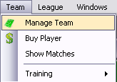

You can access the manage team screen which is the most important screen for the manager.

Here you can:

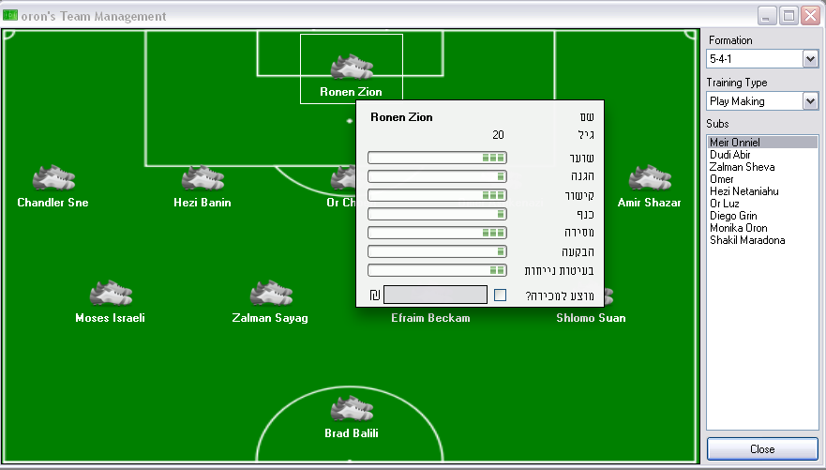

1. See player stats (go over a player).
2. Change player position (drag and drop from the subs lists or the field positions).
3. Change team formation using the formation box in the top right corner
4. Set the training type using the box. (Later you can train all teams using the menu:   
   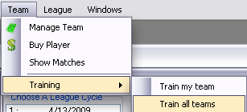

**League Cycles Form:**

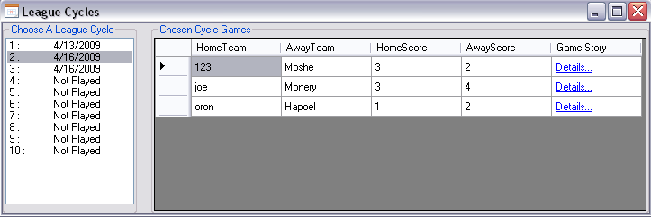

1. Open using League -> League Cycles.
2. With this form you can see which games were played during the specific cycles.
3. You can also look at game details and go the game display form.
4. It is possible to open the form and see only your team games (Team->Show Matches).

**Playing a cycle**:

Once you feel that the team is ready for the next match – use the menu to play a cycle and then you can watch the results in the team league.

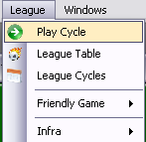

**Game Story Form:**

By clicking the details for a played game – you can view the game details.

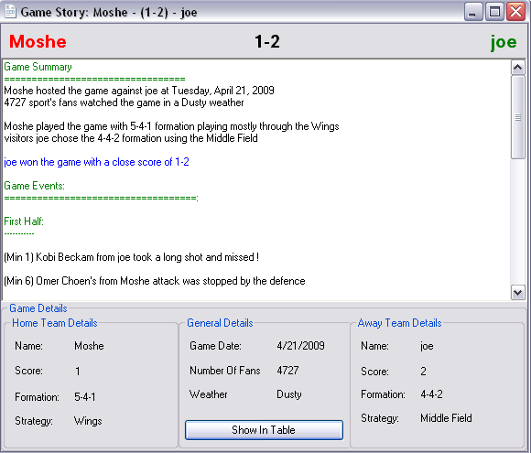

**System requirements:**

Dotnet framework 3.5.

At least 10 MB of free space.

Internet connection (for first use).